DATA ANALYSIS AND DATA SCIENCE PROJECT

Project Title: Superstore Sales Analysis:

Introduction:
- What the project is about
- The purpose of analyzing the Superstore dataset
- Tools used (Python, Google Colab, Power BI)
- Objective: analyze trends, visualize data, predict profit
Example:
"This project analyzes the Superstore sales dataset to understand sales trends, profits, and product performance. Python in Google Colab was used for data cleaning and analysis, and Power BI was used to create an interactive dashboard. The goal was to identify high-performing categories and regions and predict profit using Linear Regression."

Dataset Description:
Include:
- Number of rows and columns
- Key columns: order_id, sales, profit, category, sub_category, region, order_date
- Sample of data (first 5 rows)
- Mention missing values and duplicates if any

Data Preprocessing:
- Removed duplicates
- Handled missing values
- Cleaned column names (lowercase, underscores)
- Selected numeric columns
- Created calculated fields (e.g., Average Profit per Order)
- Optional: Add a screenshot of the code

5. Exploratory Data Analysis (EDA):

- Line Chart: Sales trend over time
- Scatter Plot (Sales vs Profit): Correlation and outliers
- Pie Chart: Sales distribution by category
- Box Plot: Profit distribution across categories
Include screenshots of charts.

Key Performance Indicators (KPIs):

- Total Sales = SUM(sales)
- Total Profit = SUM(profit)
- Total Orders = COUNT(order_id)
- Average Profit per Order = SUM(profit)/COUNT(order_id)

Machine Learning (Linear Regression):

- Selected features (sales, quantity) and target (profit)
- Split data into training and testing sets
- Scaled features
- Trained Linear Regression model
- Evaluated with R² Score and MSE
- Optional: Add scatter plot of predicted vs actual profit

Dashboard (Power BI):

- Charts included (Line, Column, Pie, Box Plot)
- KPIs displayed
- Slicers for filtering (Region, Category, Order Date)
- Insights from dashboard

Overall dashboard:
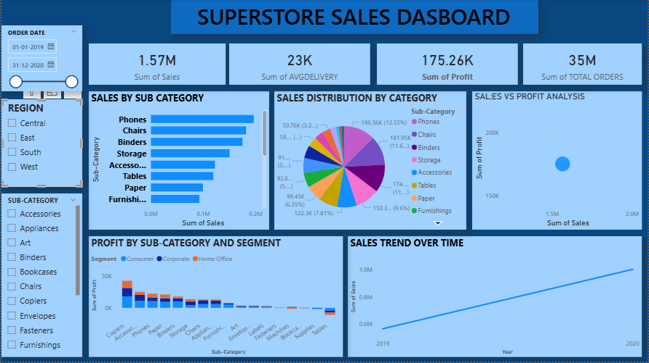

Insights and Conclusion:

- High-performing categories and regions
- Sales and profit trends
- Outliers or unusual patterns
- How this analysis can help business decisions

Example:
"The analysis shows that certain categories and regions contribute more to profit. Monitoring these KPIs helps businesses make informed decisions and optimize strategies for better performance."

